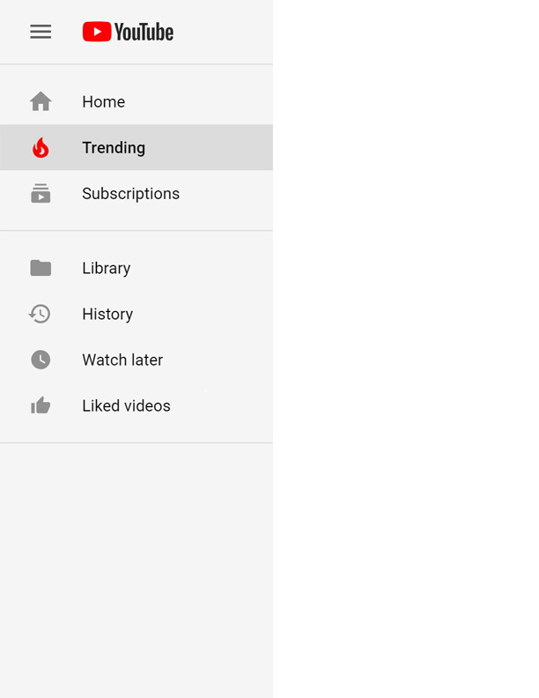

**Analyzing the YouTube Trending List**

**IT 518/418 Group Project**

